Recruitment Email for AI Workshop

Subject: Leveraging AI Tools: A Practical Workshop for Time-Strapped CRNA Faculty

Dear FANA Conference Attendee,
You are invited to attend a workshop during the 2026 Sand & Surf Anesthesia Symposium, in Orlando, Florida on Sunday, April 12th 8:00 a.m. - 9:00 a.m.
This workshop, titled Leveraging AI Tools: A Practical Workshop for Time-Strapped CRNA Faculty, is designed specifically for current & aspiring nurse anesthesia faculty. In this interactive, one-hour workshop, we will train attendees on how to use artificial intelligence (AI) to streamline their academic workload.
Specifically, we will cover how to use AI to:
- Map Course Outcomes: Instantly align your outcomes to COA Graduate Standards and AACN DNP Essentials (Domains, Competencies, and Sub-Competencies).
- Improve Curriculum Design: Write measurable, performance-based course outcomes.
- Streamline Assessment: Generate multiple-choice question items tailored to your specific course content.
- Enhance Test Item Quality: Review existing test questions to identify common flaws, such as ambiguity, cueing, and multiple correct answers.
To get the most out of the workshop, please:
- Bring a fully-charged LAPTOP and
- Have your Gmail account login information handy
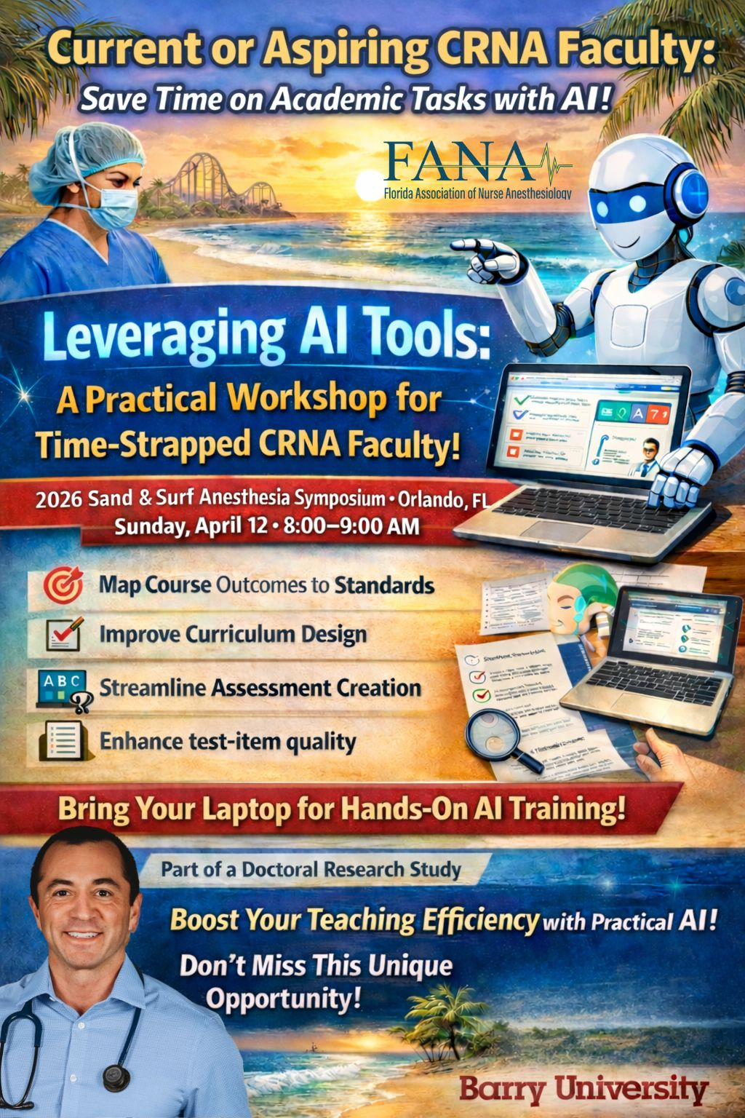
This workshop is part of a doctoral research study conducted by Jason Duprat, a DNP student at Barry University. We have attached the study details below:
--------------------------------------------------------------------------------

This workshop is part of a doctoral research study conducted by Jason Duprat, MBA, MSA, CRNA, APRN, a DNP student at Barry University.
Purpose of the Study: Jason Duprat is evaluating whether a brief, hands-on workshop improves current and aspiring faculty self-efficacy in using AI tools for the academic tasks listed above.
Voluntary Participation: Your participation in the survey is entirely voluntary. You are welcome to attend the workshop and learn these AI tools without participating in the research study or completing the surveys. If you choose to participate in the research component, you will be asked to complete two brief, anonymous electronic surveys (one pre-workshop and one post-workshop).
Survey Time Commitment: Approximately 10 minutes total for both surveys.
Contact Information If you have questions about the research or your rights as a participant, please contact:
- Principal Investigator: Jason Duprat, MBA, MSA, CRNA, APRN Email: jason.duprat@mymail.barry.edu Cell: 716-984-4103
- Faculty Sponsor: Dr. Dawn Welliver, DNP, CRNA, APRN Email: dwelliver@barry.edu Office: 954-579-1187
- Barry University Institutional Review Board (IRB): Ms. Anoush McNamee Email: amcnamee@barry.edu Phone: 305-899-3020

